Number of Buildings = 21

Number of Health Packs = 4

Map co-ordinates = (10986 , 10962)

Length of map = 15519.6

Speed of player = (57)

Time = (272.273) seconds

Theme = (3) = Village

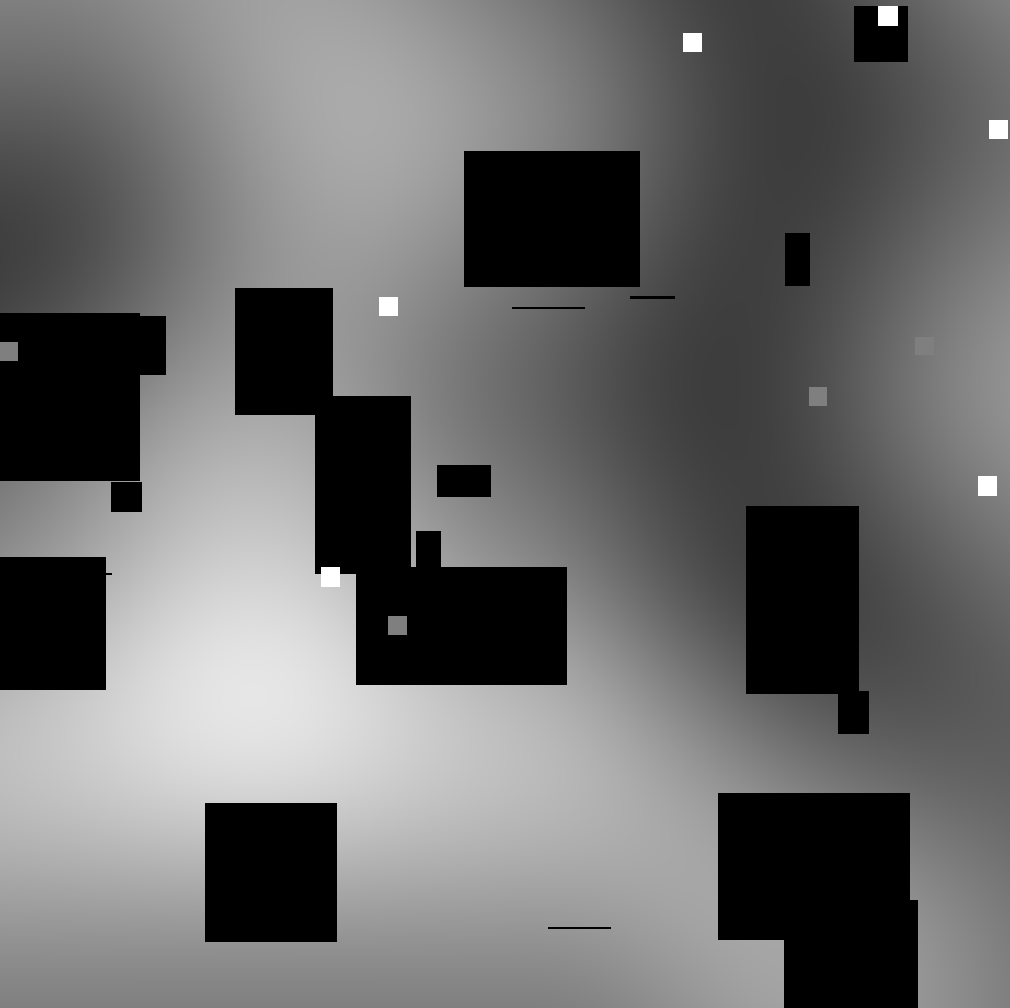Number of Sides = (1) Right